ESP32-LoRa Coastal Flood Monitoring System

Progress Report

**Team: Tide Watch**

**Date: June 26, 2025**

**Project Duration: June 2025 - Ongoing**

**Institution: University of Ghana, Accra**

**Gaiathon 2025**

Abstract

This report presents the current progress on developing an autonomous coastal flood monitoring system utilizing ESP32 microcontrollers with LoRa wireless communication technology. The system is designed to provide real-time water level monitoring and early warning capabilities for coastal communities in Ghana. The proposed solution integrates multiple environmental sensors including DHT22 temperature-humidity sensors, BMP280 atmospheric pressure sensors, and water level detection mechanisms deployed on a solar-powered floating platform. Data transmission occurs via LoRa protocol to a Raspberry Pi 4 gateway, which processes threshold violations and triggers local alarm systems while caching data for efficient cloud transmission. Current progress includes successful component procurement, initial sensor integration with ESP32, and preliminary system architecture design. The system aims to provide cost-effective, reliable flood monitoring with minimal infrastructure dependencies suitable for remote coastal deployment.

Keywords: Coastal monitoring, LoRa communication, ESP32, flood detection, IoT sensors, early warning systems

Introduction

Coastal flooding poses significant risks to communities along Ghana's coastline, necessitating reliable early warning systems. Traditional monitoring infrastructure often requires extensive telecommunications networks and constant power supply, making deployment in remote coastal areas challenging. This project addresses these limitations by developing a self-contained, solar-powered monitoring system utilizing Long Range (LoRa) wireless technology for data transmission.

The system architecture comprises three main components: (1) a floating sensor node based on ESP32 microcontroller with environmental sensors, (2) a land-based Raspberry Pi gateway for data processing and alarm activation, and (3) a data caching and transmission system for reliable cloud connectivity. This approach ensures continuous monitoring capability even with intermittent internet connectivity while providing immediate local alerts for dangerous conditions.

Literature Review

*LoRa Technology in Environmental Monitoring*

Long Range (LoRa) technology has emerged as a preferred solution for remote environmental monitoring applications due to its long-range capabilities (up to several kilometres), low power consumption, and ability to operate without existing telecommunications infrastructure. Previous implementations have demonstrated successful deployment of LoRa-based sensor networks for water level monitoring, achieving transmission ranges exceeding 200 meters with standard hardware and up to tens of kilometers under optimal conditions with line-of-sight deployment.

Threshold Detection Algorithms

Effective flood monitoring requires robust threshold detection algorithms to minimize false alarms while ensuring rapid response to genuine threats. Literature emphasizes the use of hysteresis-based threshold systems employing dual set points (upper and lower thresholds) with state variables to prevent oscillation. This approach, combined with temporal persistence requirements, has proven effective in reducing noise-induced false triggers while maintaining system responsiveness.

Solar-Powered IoT Deployments

Studies from high-latitude deployments (Stockholm, Sweden) demonstrate that modest solar panel configurations (2.5-5W) can sustain frequent LoRa transmissions year-round, even under challenging winter conditions. For Ghana's tropical climate with abundant solar radiation, similar configurations are expected to provide reliable year-round operation with appropriate battery backup systems.

Buoy Design and Maritime Deployment

Maritime sensor platforms require careful consideration of buoyancy, stability, and waterproofing. Successful designs typically employ foam-filled polyethylene shells or sealed plastic containers with weighted keels for stability. Waterproofing standards of IP68 or higher are essential for electronics protection, with marine-grade materials recommended for long-term deployment.

System Design and Architecture

*Overall System Architecture:*

The coastal flood monitoring system employs a distributed architecture with the following key components:

1. Floating Sensor Node (ESP32-based) [currently]

2. Land-based Gateway (Raspberry Pi 4)

3. Local Alarm System

4. Data Caching and Cloud Transmission System6

Floating Sensor Node Design

*Hardware Configuration*

* Primary Controller: ESP32 Development Board (WiFi+Bluetooth Dual Core 38Pin)
* Communication: RA-02 LoRa module with antenna
* Environmental Sensors:
* DHT22 temperature-humidity sensor (×2)
* GY-BMP280 atmospheric pressure sensor (×2)
* Water level sensor (implementation pending)
* Power System: 6V 2W solar panel with 12V 7.2AH deep cycle battery
* Power Management: Multi-output DC-DC converter (12V to 3.3V/5V/12V)

Data Packet Structure

The system transmits data in JSON format optimized for LoRa payload constraints:

```**json**

{

"wave_height": {"normal": 0.0, "warning": 2.5, "critical": 4.0},

"water_height": {"normal": 1000.0, "warning": 1250.5, "critical": 1400},

"temperature": {"normal": 30.0, "warning": 21.0, "critical": 16.0},

"humidity": {"normal": 70.0, "warning": 85.0, "critical": 90.0},

"air_pressure": {"normal": 1014, "warning": 1010.0, "critical": 1008.0}, # lower is worse

"wind_speed": {"normal": 10.0, "warning": 20.0, "critical": 25.0},

"timestamp": "2025-06-15T10:00:00Z"

}

```

Threshold Detection Algorithm

The system implements a dual-threshold approach with hysteresis:

```

if (water_level > high_threshold &&! alarm_triggered) {

alarm_triggered = true;

transmit_alert();

} else if (water_level < low_threshold && alarm_triggered) {

alarm_triggered = false;

transmit_clear();

}

```

Gateway and Alarm System

Raspberry Pi 4 Gateway

* Hardware: Raspberry Pi 4 Model B (1GB RAM) starter kit
* Functions:
* LoRa packet reception and parsing

- Threshold violation detection

- Local alarm activation

- Data caching and batch transmission

- MQTT protocol implementation

Alarm System Integration

Local alarm activation utilizes the Raspberry Pi's audio output capabilities:

* Primary Method: Audio jack output for buzzer/siren activation
* Backup Method: GPIO-controlled relay systems for external alarms
* Alert Duration: Configurable alert periods with automatic reset

Web-Based Monitoring Dashboard

To complement the hardware system and enhance real-time data accessibility, a web-based monitoring dashboard was developed using Node.js and Next.js. This dashboard interfaces with the Raspberry Pi gateway to visualize environmental sensor data including water level, wave height, temperature, humidity, air pressure, and wind speed.

The dashboard allows stakeholders to view current sensor readings and system status from any network-connected device. Built with performance and scalability in mind, it features asynchronous data fetching, dynamic component rendering, and secure backend APIs for data interaction. This platform supports both local visualization and future cloud integration, laying the groundwork for centralized monitoring and analytics across multiple coastal sites.

By leveraging modern JavaScript frameworks, the system benefits from a modular, maintainable codebase and responsive user interface, which aligns with the project’s long-term vision of community-wide alerting and decision support.

Data Caching and Transmission Strategy

*Caching Rationale:*

Local data caching provides several critical benefits:

* Bandwidth Optimization: Reduces network transmission requirements
* Network Reliability: Maintains operation during connectivity interruptions
* Cost Efficiency: Enables batch transmission to minimize data costs
* Data Integrity: Prevents data loss during server outages

Implementation Approach

* Storage Options: SQLite database for structured data storage
* Caching Period: 6-12 hour intervals before cloud transmission
* Transmission Protocol: MQTT (Mosquito) for reliable data delivery
* Fall-back Mechanisms: Local storage expansion during extended outages

Component Procurement

Successfully acquired all primary system components as documented in Invoice OE-3176 (June 9, 2025) which was issued in order to receive funding for procuring the components.

Funding was acquired on June 13, 2025.

Order was issued on June 13, 2025.

Items were delivered on June 18, 2025.

Completed Acquisitions:

* ESP32 development boards and supporting components
* DHT22 temperature-humidity sensors (×2)
* BMP280 atmospheric pressure sensors (×2)
* Solar power system components
* Raspberry Pi 4 gateway hardware
* Jumper wires and connectivity components

Total Investment: ₵2,302.00

Sensor Integration Progress

* DHT22 Integration: Successfully established communication between DHT22 sensors and ESP32
* Data Reading Capability: Confirmed ability to read temperature and humidity data
* Integration of BMP280 pressure
* Next Phase: sensors water level detection

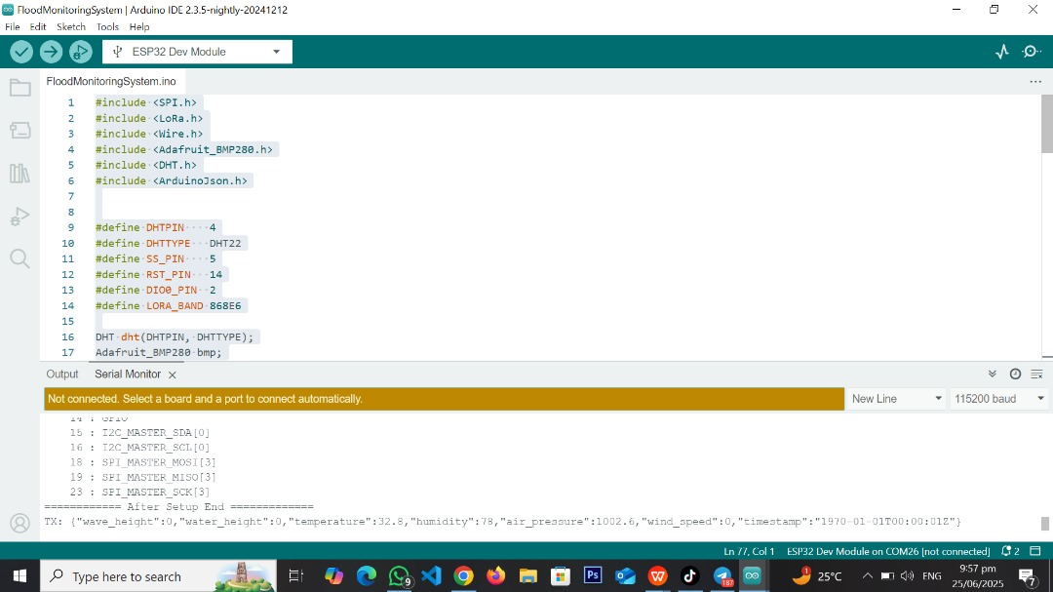

Communication System Development

* LoRa Module: RA-02 LoRa module procured with antenna
* Protocol Selection: Standard LoRa point-to-point communication protocol
* Development Environment: Arduino IDE/PlatformIO setup in progress

Power System Design

* Solar Panel: 6V 2W solar panel for primary power generation
* Battery Backup: 12V 7.2AH deep cycle battery for continuous operation
* Power Management: Multi-output DC-DC converter for voltage regulation

Planned Implementation Phases

Phase 1: Planning and Requirement [Completed]

* Problem recognition and solution brainstorming
* Solution selection and goal definition
* Checking constraints and Risk analysis
* Proposal reading

Phase 2: Components Acquisition, Setup and Gateway Development

* Complete sensor integration and calibration
* Develop LoRa communication protocols
* Implement threshold detection algorithms
* Test power management systems
* Configure Raspberry Pi LoRa reception
* Implement data caching mechanisms
* Develop alarm activation systems

Phase 3: System Integration and Laboratory Testing

* End-to-end communication testing
* Alarm system validation
* Data transmission optimization
* System reliability testing

Phase 4: Deployment Preparation

* Waterproof enclosure design and testing
* Floating platform construction
* Marine environment preparation
* Installation procedures development

Technical Challenges and Considerations

Environmental Challenges

Waterproofing: Ensuring IP68 protection for electronics

Corrosion Resistance: Marine environment material selection

Wave Action: Maintaining sensor stability and accuracy

Solar Exposure: UV protection for electronic components

Communication Challenges

* Range Optimization: Maximizing LoRa transmission distance
* Power Efficiency Balancing transmission frequency with battery life
* Data Integrity: Ensuring reliable packet transmission
* Interference: Managing RF interference in coastal environments

Mechanical Design Challenges

* Buoyancy Design: Creating stable floating platform
* Anchoring System: Securing platform while allowing sensor access
* Maintenance Access: Designing for periodic maintenance and calibration
* Storm Resistance: Ensuring system survival in adverse conditions

Expected Outcomes and Future Work

Immediate Objectives

- Complete sensor integration and testing

- Establish reliable LoRa communication

- Develop prototype threshold detection system

- Begin gateway software development

Medium-term Goals (1-2 weeks)

- Complete system integration testing

- Develop and test floating platform prototype

- Implement data caching and transmission systems

- Conduct preliminary field testing

Long-term Vision

- Deploy operational monitoring system

- Establish community alert networks

- Expand to multiple coastal monitoring points

- Integrate with national disaster management systems

Conclusion

The ESP32-LoRa coastal flood monitoring system project has achieved significant progress in component procurement and initial system design. The successful acquisition of all primary hardware components and establishment of basic sensor communication demonstrates project feasibility. The proposed architecture addresses key challenges of remote coastal monitoring through solar power independence, LoRa communication reliability, and intelligent data caching strategies.

Current progress positions the project for successful completion of laboratory testing phases and progression toward field deployment. The combination of proven technologies (ESP32, LoRa, environmental sensors) with innovative integration approaches provides a solid foundation for creating an effective coastal monitoring solution suitable for Ghana's coastal environments.

The next critical phase involves completing sensor integration, establishing reliable LoRa communication protocols, and developing the gateway processing systems. Success in these areas will enable progression to prototype testing and eventual field deployment, contributing to improved coastal safety and disaster preparedness capabilities.

Recommendations

* Extra work to be completed if data caching is to be a major part of the project. For future improvement, online cloud setup and storing of data to serve as an informant for other discoveries and availability to the general public.
* Project must be taken as a long term work. The project needs to be developed over an extensive period which the team lacked as at the time of work hence the minimum working version was built in the given timeframe.
* SMS as a form of communication to the coastal communities can serve as an extensive future integration into the project.

References

1*. Sandeep Mistry Arduino-LoRa Library Documentation*

*2. The Things Network (TTN) LoRaWAN Implementation Guidelines*

*3. ESP32 Technical Reference Manual, Espressif Systems*

*4. Maritime Sensor Platform Design Guidelines, Various Technical Sources*

*5. Solar Power Systems for IoT Applications, Academic Research*

*6. Threshold Detection Algorithms for Environmental Monitoring*

*7. MQTT Protocol Specifications for IoT Applications*

Team Tide Watch

University of Ghana, Accra